Resolve Merge Conflicts.
1)Create a merge conflict intentionally (two users editing the same line).
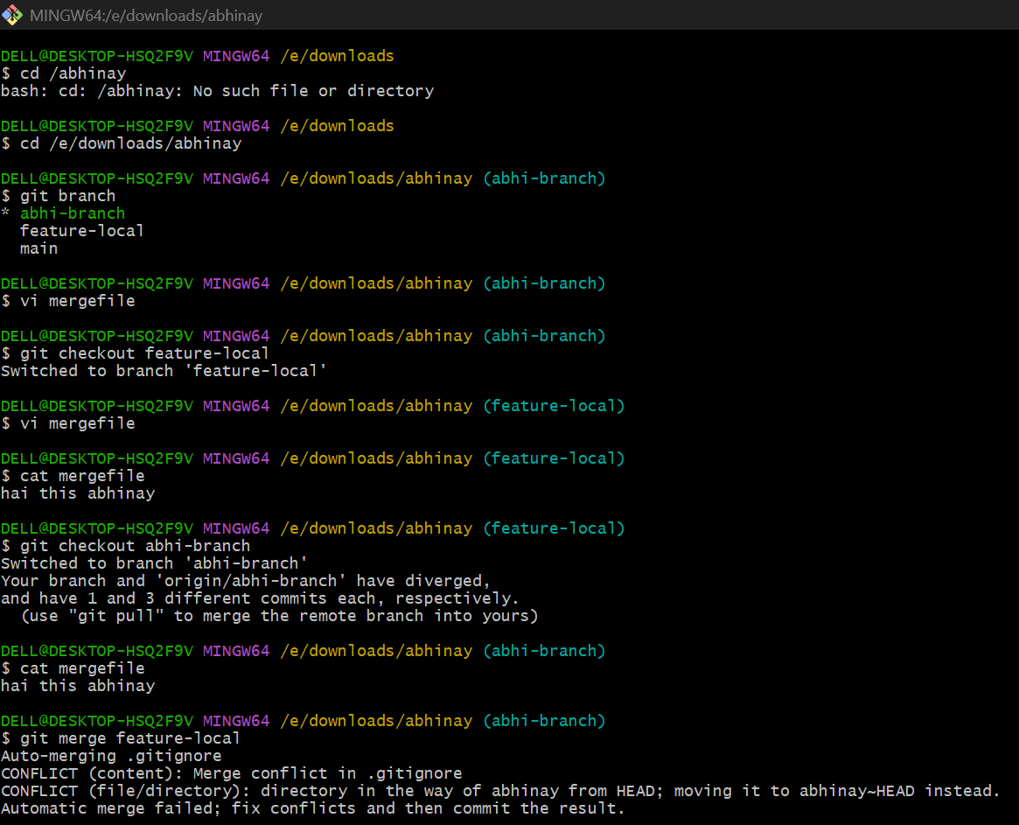
2) Resolve the conflict and push the changes.
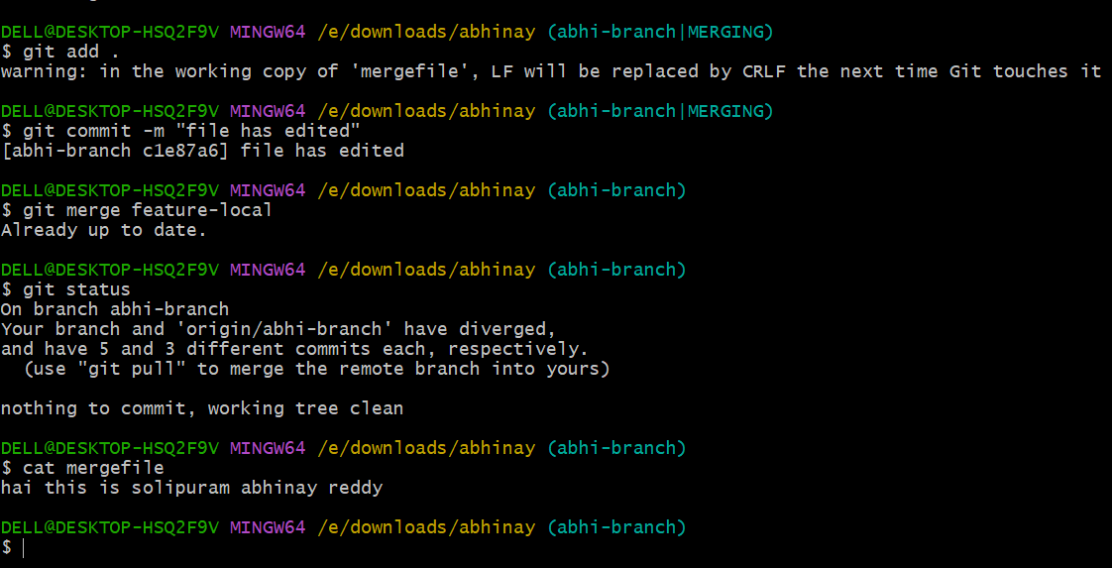

Recover Deleted Branch
1)Delete a local branch and then recover it using the reflog.
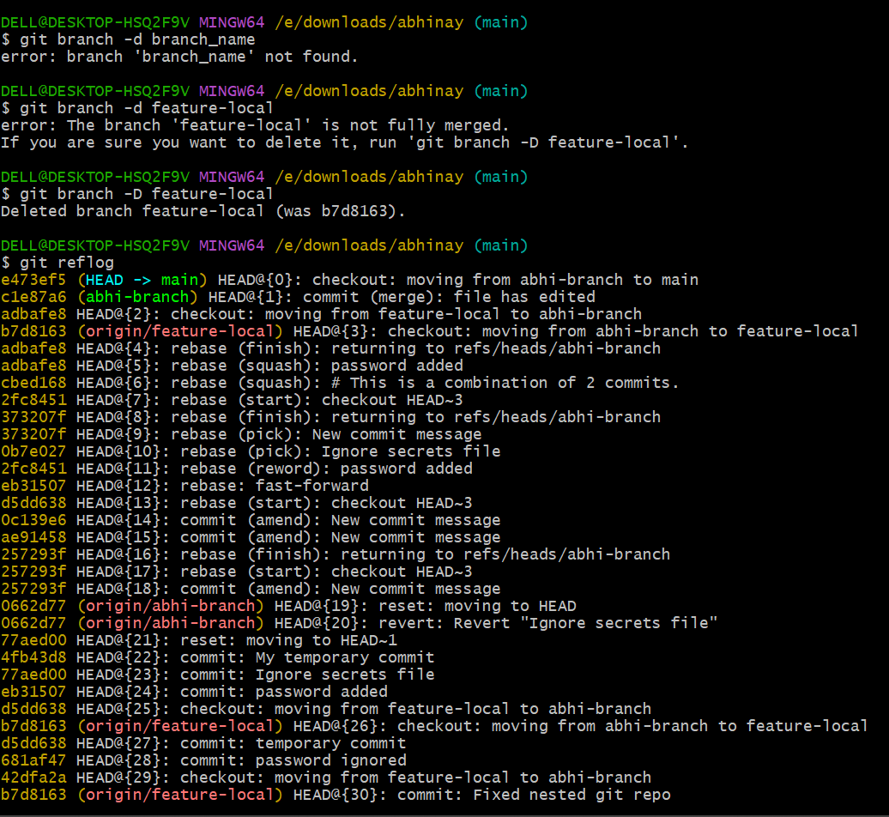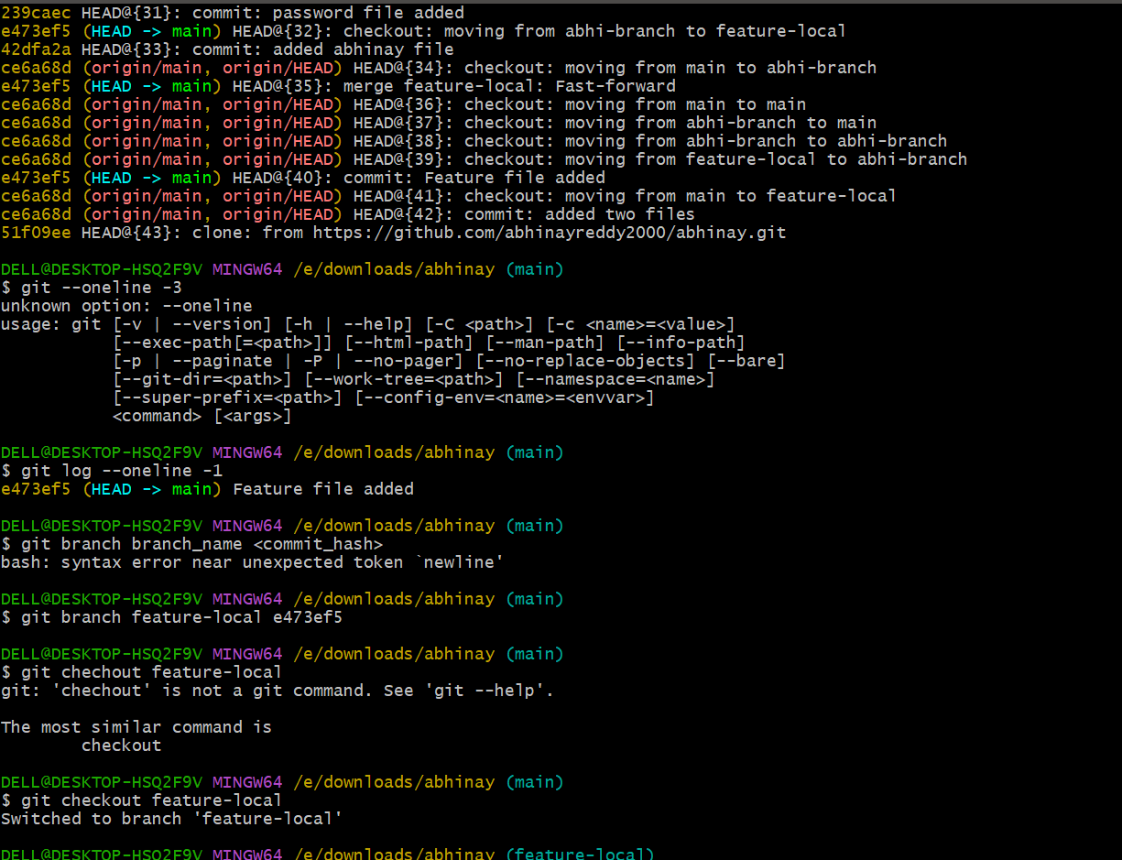

Undo Wrong Push.
Push a wrong commit to GitHub, then undo it without losing history.

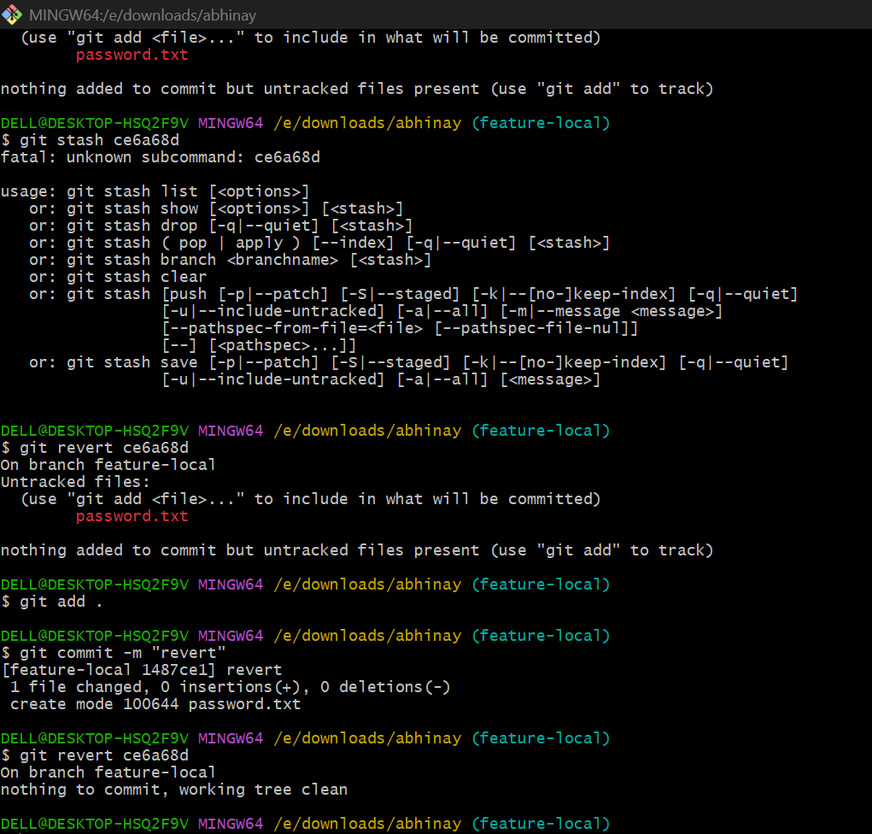

Amend a Commit
Make a commit, then add a missing file to it using git commit --amend.
- Make your first commit (without the missing file)
git add file1.txt
git commit -m "Initial commit"

- Realize you forgot a file (example: file2.txt)
git add file2.txt
- Amend the last commit to include it
git commit --amend
- Verify
git show --stat

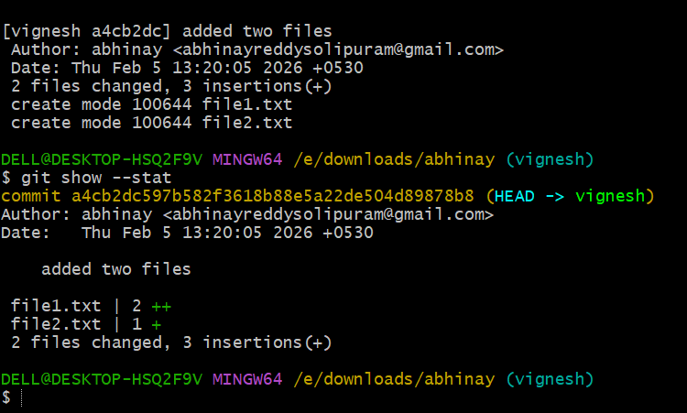
Cherry-pick a Commit
Take a specific commit from one branch and apply it to another branch
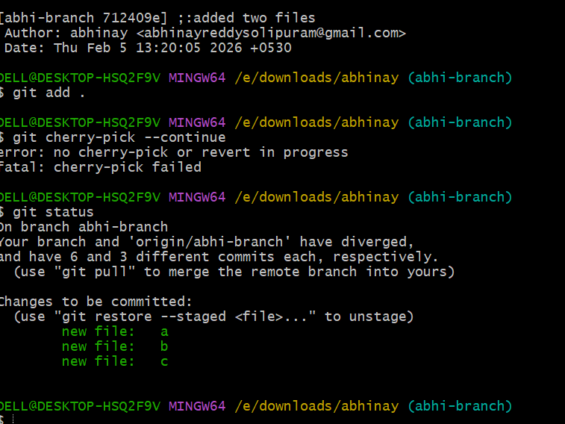

Interactive Rebase
Reorder and squash multiple commits into a single clean commit.

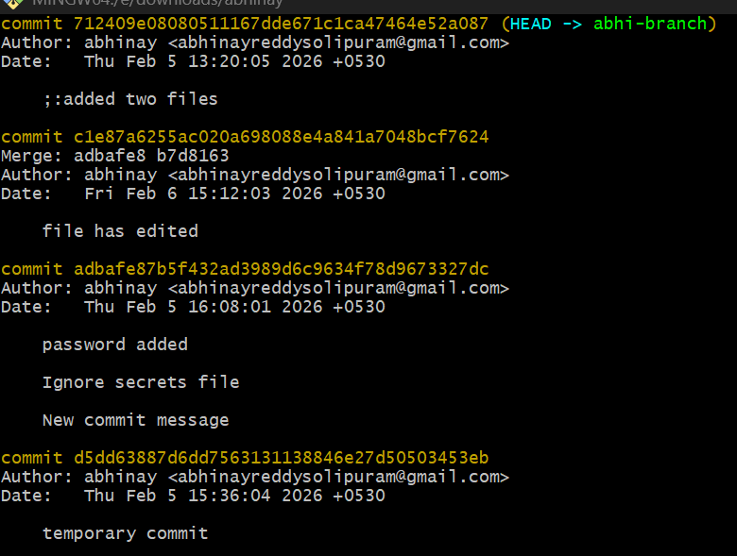

Tagging & Release
Create a version tag (v1.0), push it to GitHub, then delete and restore it.
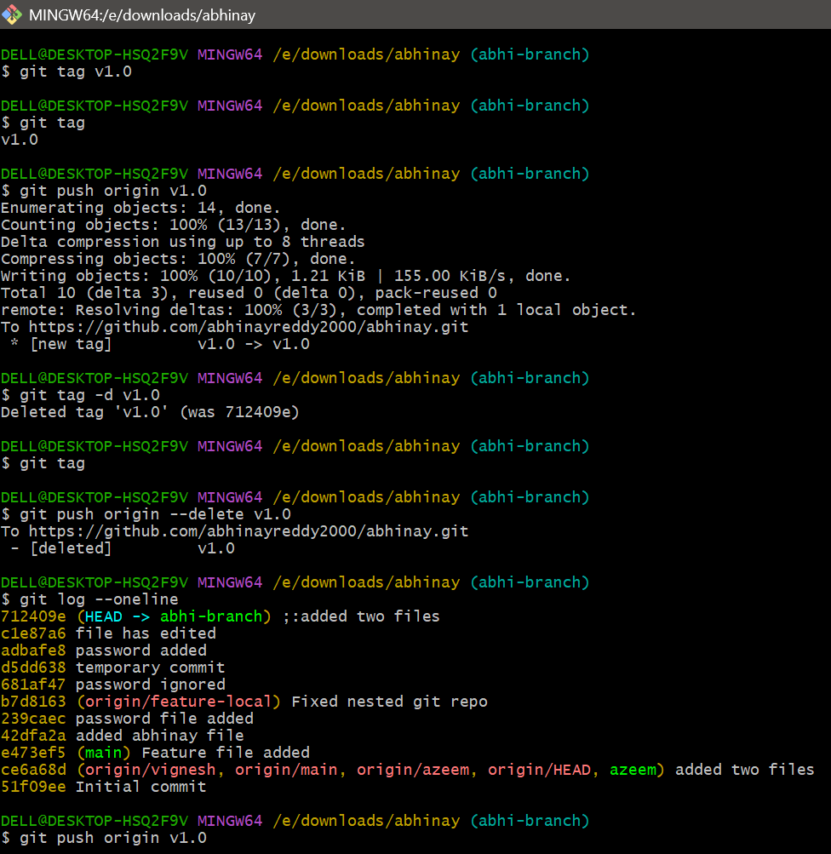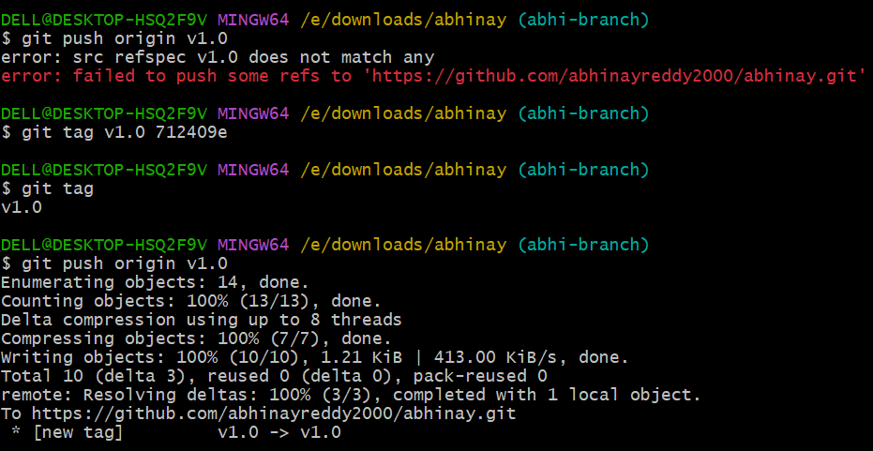

Clone with Sparse Checkout
Clone only a subdirectory of a repo using sparse checkout.
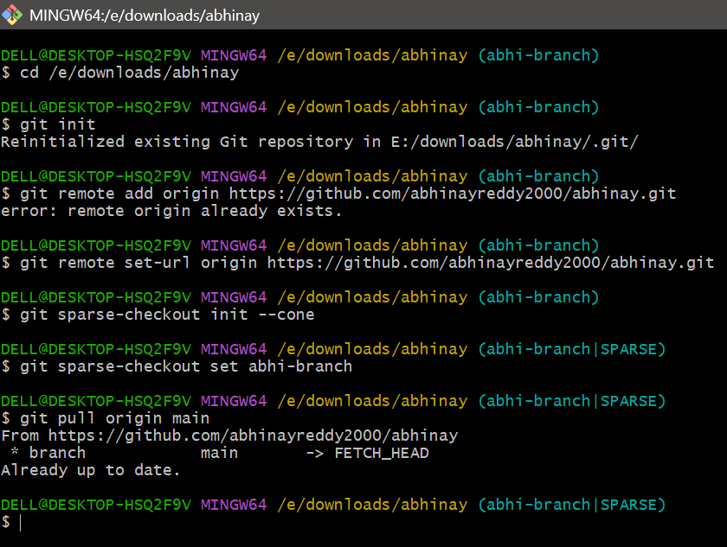
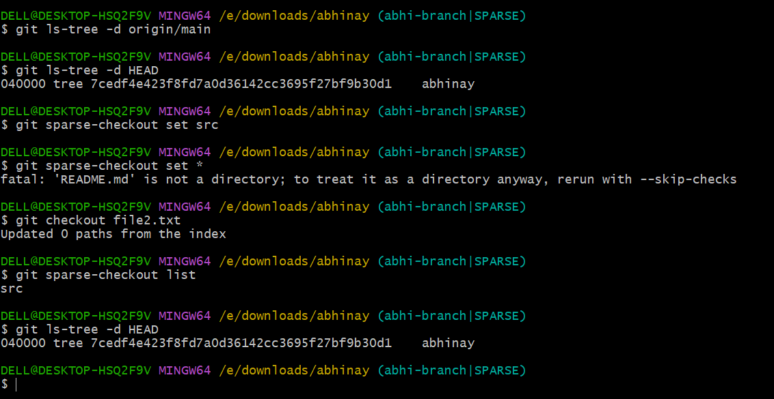

Challenge Reset vs Revert
Demonstrate the difference between git reset --hard and git revert in a repo. 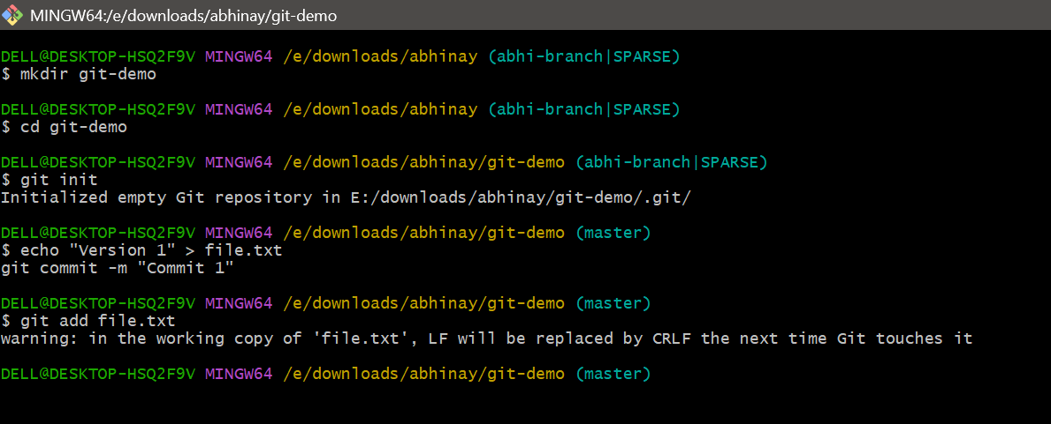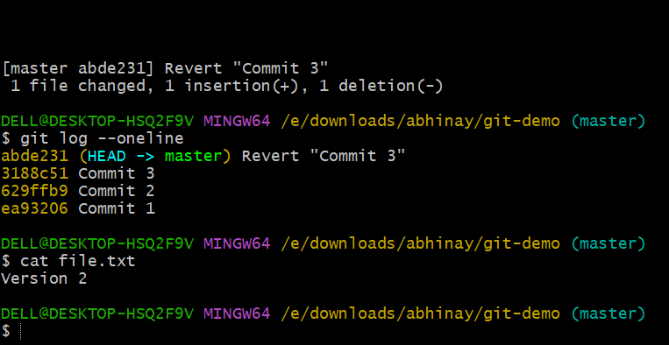

Detached HEAD Challenge
Checkout a specific commit (detached HEAD state) and create a new branch from it. 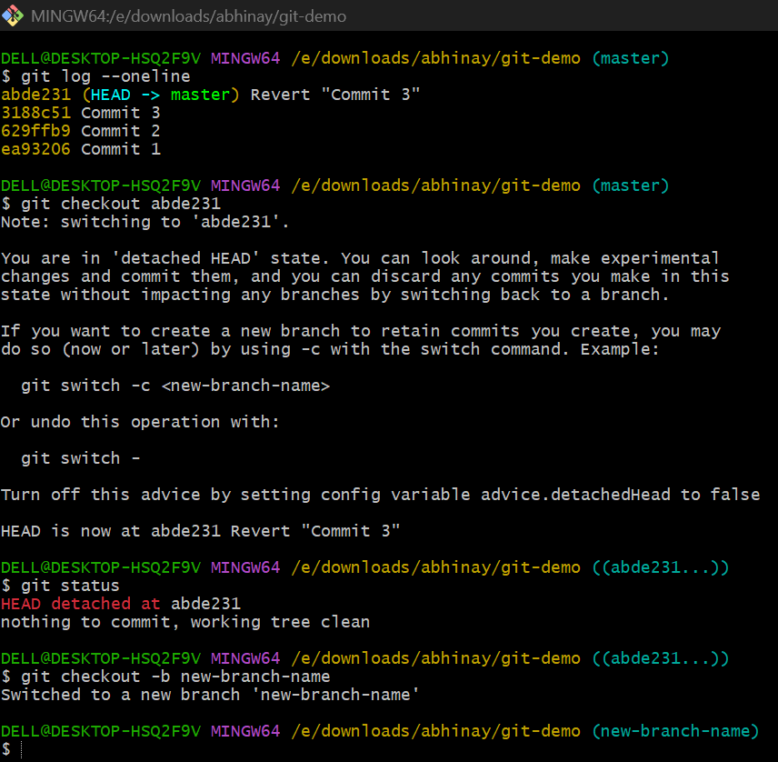
Git Hooks Challenge
Configure a pre-commit hook to reject commits without a message format (e.g., must start with JIRA-XXX).
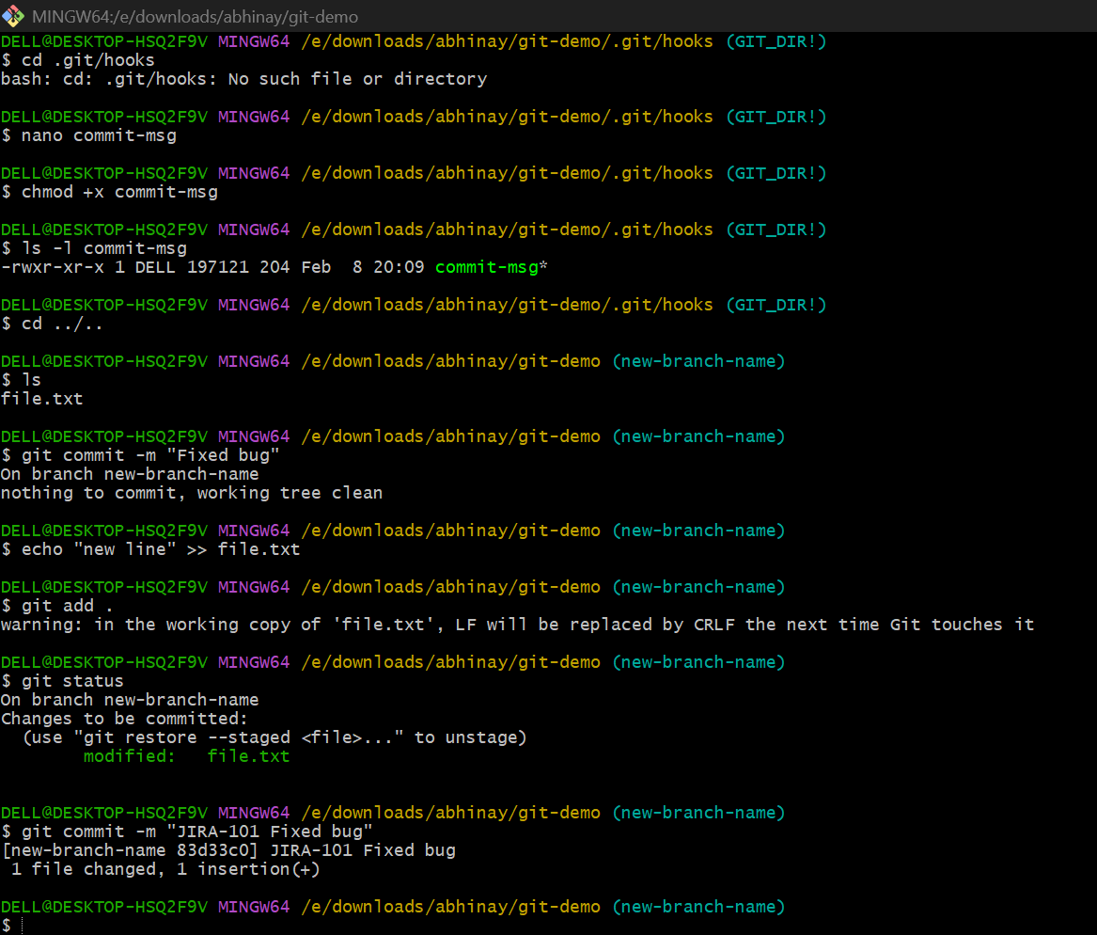

Squash Merge vs Rebase Merge
Show the difference between squash merge and rebase merge with evidence.
Squash merge
Squash merge combines all feature branch commits into a single, new commit on the main branch, ideal for creating a clean, concise project history.
History: Squash creates one commit.
Detail: Squash loses individual commit history.
Complexity: Squash is generally easier to revert (one commit to undo)
When to Use
- Squash Merge: Best for cleaning up messy, work-in-progress ("WIP") commits in a feature branch before merging to main.

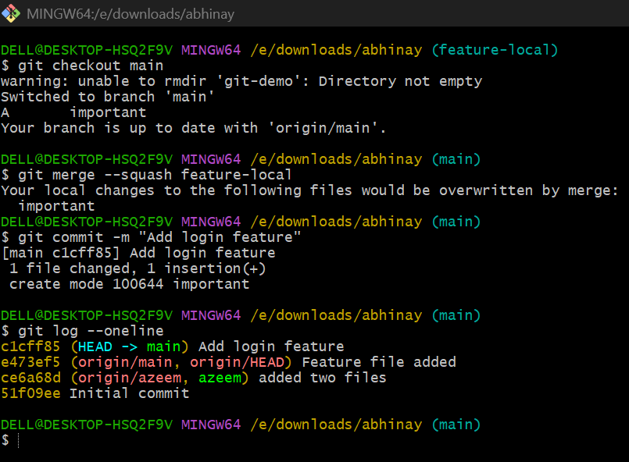
Rebase merge
Rebase merge moves the entire feature branch history onto the tip of the main branch, creating a linear history without a merge commit.
Rebase Merge: Best for keeping a perfectly linear history, often used when keeping feature commits distinct is important.
History: Rebase preserves all original commits but linearizes them.
Detail: Squash loses individual commit history, whereas Rebase keeps them.
Complexity: Squash is generally easier to revert; Rebase can be complex if conflicts arise.
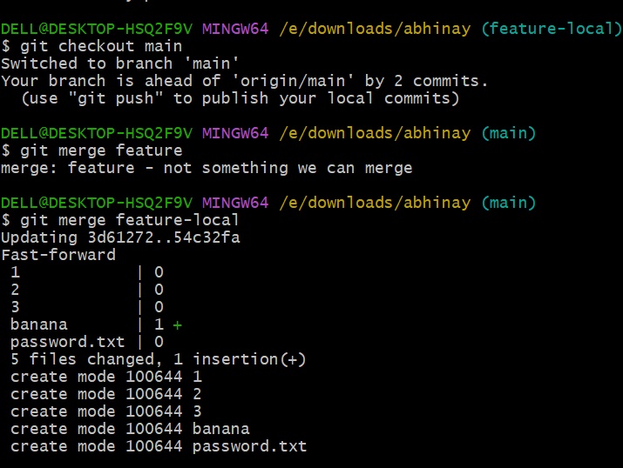

Fork & Pull Request Workflow
Fork a repo, make a change, and submit a pull request to the original repo.
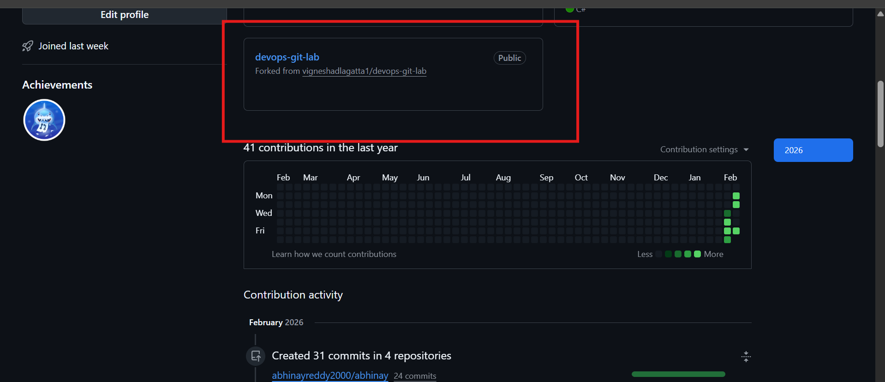
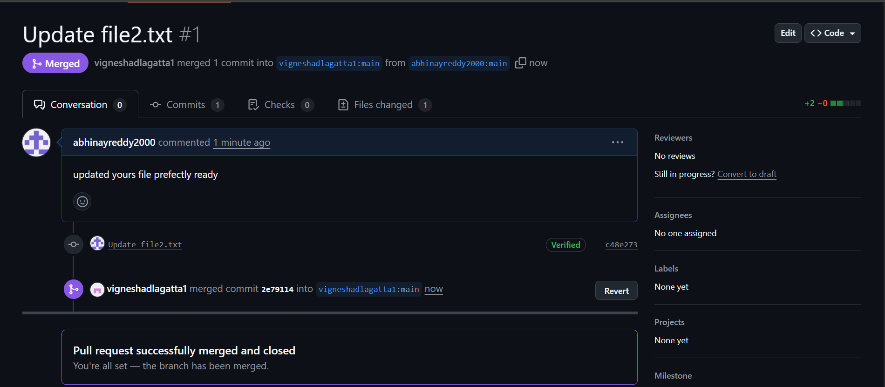
Recover Lost Commit
- Commit something, reset hard, and then recover it using git reflog.

